Speed and Pothole Detection

1. Introduction

The first automobile was made in 1769, even though it was not even near to what we know it is today, and it changed the world, suddenly we were able to move from a point to another in very efficient way. But we didn’t stop there, we made upgrades to the basic design of what an automobile was, making it better in many ways, and one of the most important fields to make improvements was in safety.

An impressive number of tests are made for the sake of the safety in every part of a car, from crash tests to electrical tests to ensure that an electric malfunction would not harm the driver, but by today standards, these safety measures are not enough, we live in a world with sensors of every kind everywhere, and cars are not an exception for this, being for forced safety measure or maybe just for the sake of getting statistics on the values of the car, we add an incredible amount of sensor to our automobiles.

In this paper, we describe the combination of two different sensors to be able to measure the speed, if the car is over speeding and if there is a pothole on the road. For this we make use of an ultrasonic sensor to detect potholes, two infrared sensors to be able to detect the speed, a piezoelectric buzzer to alert the over speeding, and an Arduino UNO to be able to control de whole system.

1. Background & Modifications

We based our project on the “Car Speed Detector” tutorial created by Muhammad Ansar in the Arduino Project Hub at create.arduino.cc, in this project, Muhammad uses infrared sensors (IR) to be able to measure the speed of an object, in this case a car, while it passes through a road. Both IR sensors are placed in a known distance from each other, and the Arduino is in charge of measuring the time taken by the object from activating the first IR sensor and the next one, after that, the Arduino uses a LCD screen to show the speed of the object and will activate a buzzer if the speed is too high.

We are adding to this concept an ultrasonic sensor that will be in charge of detecting any pothole in the road, which could be data used by any other security measure to take actions to protect the driver and other drivers in the same road.

1. Build Preparation

To be able to do the software of the project Arduino IDE, and its basic library, is necessary.

The following specific materials are required for the project:

* Arduino UNO
* HC-SR04 Ultrasonic Sensor

Additional general materials required:

* Piezoelectric Buzzer
* 2x IR collision sensors
* Breadboard
* Jumper and wires

1. Design and Build

The design is very straightforward, each sensor just does basic functions that will be taken by every GPIO that the Arduino has available, maybe the most “complicated” one is the ultrasonic sensor which is very simple in reality, it just needs a source voltage on its VCC pin, which is provided by the Arduino since it doesn’t need much current, a common reference node for its GND pin, an output GPIO connected to its trigger pin, which is in charge of telling the sensor to start the sensing process, and an input GPIO to be able to read the state of the Echo pin, which is in charge of letting the Arduino know the distance between an object and the ultrasonic sensor, later we will explain this in more detail.

On the other hand, the IR sensors just have two pins for VCC and GND respectively, and a third pin that will let the Arduino know if there is an object on front of it without knowing the distance. The last component is the buzzer, which is powered by the Arduino through a GPIO pin, this will make the buzzer make a sound. In Fig. 4, Fig. 5 and Fig. 6 can be respectively seen the IR sensor, buzzer and ultrasonic sensor, and in Fig. 9, Fig. 10, and Fig. 7, the interface of each sensor can be seen in the same order.

Normally, the ultrasonic sensor would be placed on the car, directly facing the ground at certain inclination, this makes the ultrasonic sensor able to see when there is an abnormal shape in the road, but due to some shortage on jumper, we just made test with it on a breadboard in Fig. 11 and Fig. 12, where the whole system is installed. On the other hand, the IR sensors are place on each side of the breadboard, which needs to be parallel to the direction of the car to accurately measure its speed.

1. User Manual

Preliminary setup:

* Install all the hardware according the schematics listed in Appendix A.
* Install Arduino IDE.
* Compile the code listed in Appendix C.
* Open the Serial Monitor

The code is structured so the Serial Monitor can output the speed when a car passes through the IR sensors, and it will show if there is a pothole ahead. There isn’t anything else to do than make the code run while testing its functionality with a remote controlled car.

It is worth noting how the speed calculation and the pothole detection works, in the case of the speed calculation, the Arduino will get time that the car needed to pass from one IR sensor to another, having the time, and the known distance between the two IR sensors, we are able to calculate the speed with a simple speed formula:

$$V=\frac{m}{s}$$

Where *V* is the speed of the car, *m* is the distance between the both IR sensors and *s* is the time that the car took to pass from one IR sensor to another. Have in mind that in case of the car accelerating or deaccelerating between the IR sensors, the Arduino will output the speed as an average of the change of speed.

As for the pothole detecting, we use the ultrasonic sensor, which sends an ultrasonic wave that will echo or “bounce” back to the sensor, depending on the time taken by the ultrasonic wave to go, and bounce back, the Arduino is able to calculate the distance between the sensor and the object or surface on which the ultrasonic wave bounced back. The formula used to do the calculation is:

$$m = s*\frac{0.34}{2}$$

Where *m* is the distance between an object or surface, and the sensor, and *s* is the time taken by the ultrasonic wave to go and come back.

1. Milestones & Setbacks

|  |  |  |  |  |
| --- | --- | --- | --- | --- |
| No. | Intended Date | Description | Status | Completion Date |
| 1 | October 18 | All parts gathered | Completed | October 25 |
| 2 | November 2 | Initial Assembly | Completed | November 2 |
| 3 | November 9 | Speed detector code and test | Completed | November 9 |
| 4 | November 16 | Added pothole detection to the code | Completed | November 16 |
| 5 | November 30 | Stretch goal: control the vehicle | Incomplete |  |

These milestones are different from what was stated in the previous project proposal due to problem related to the delivery of the components necessary for the project, the shipping got delayed because of the Covid-19 situation and after we got the parts, some of them came defective, so we changed some the objectives of the project.

We found out that the implementation of this project would be much more efficient and accurate if the speed calculation part had a microcontroller system for itself, another option would be to use a microcontroller with Real-Time Operating System installed, that could simulate a multicore system and improve the performance of the sensors.

1. Conclusion

There is no doubt that sensor technology in the world of automobiles is just going to keep getting better and better, there are already self-driving cars in our time and it is a technology that is just starting to bloom. Pothole detection is one of the most important things to develop, it needs to be accurate and consistent, and that will more research and development. In the case of our project, it suffers of some drawbacks like the lack of more computing cores which would improve by a lot the performance of the code. At the end, this project accomplishes to do the work of detecting potholes and the speed of a car passing through a road, by using an ultrasonic sensor and two IR sensors, this can be added to a system that could act upon these alerts, and stop the driver or car from getting into a pothole.

Appendix A

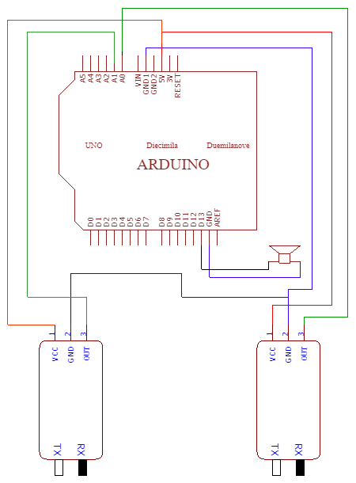

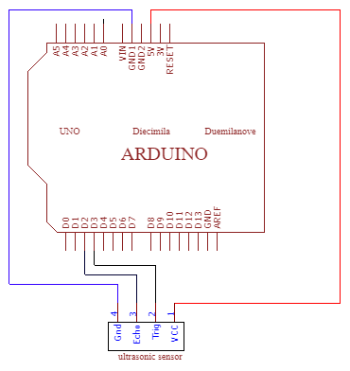

Fig. 2. IR Sensors and Buzzer Interfacing

Fig. 1. Ultrasonic Sensor Interfacing

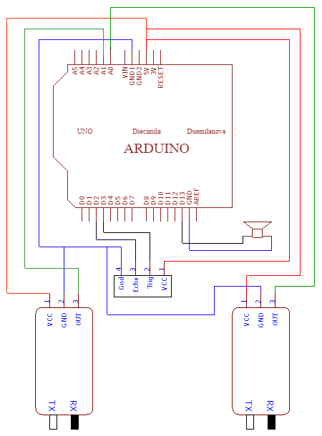

Fig. 3. System Circuit Diagram 1

Appendix B

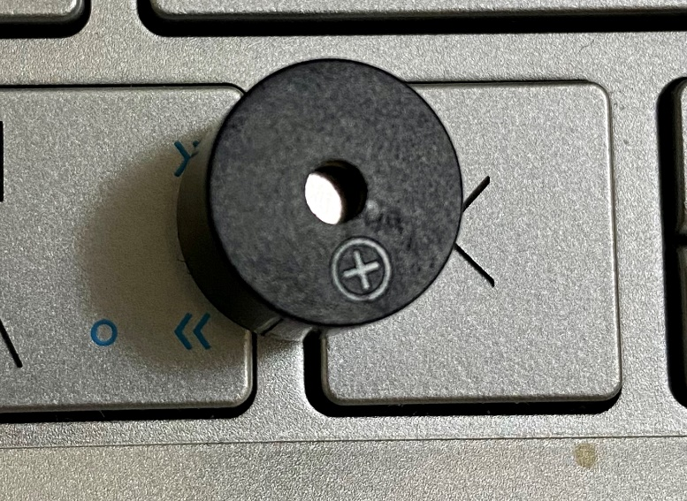

Fig. 5. Buzzer

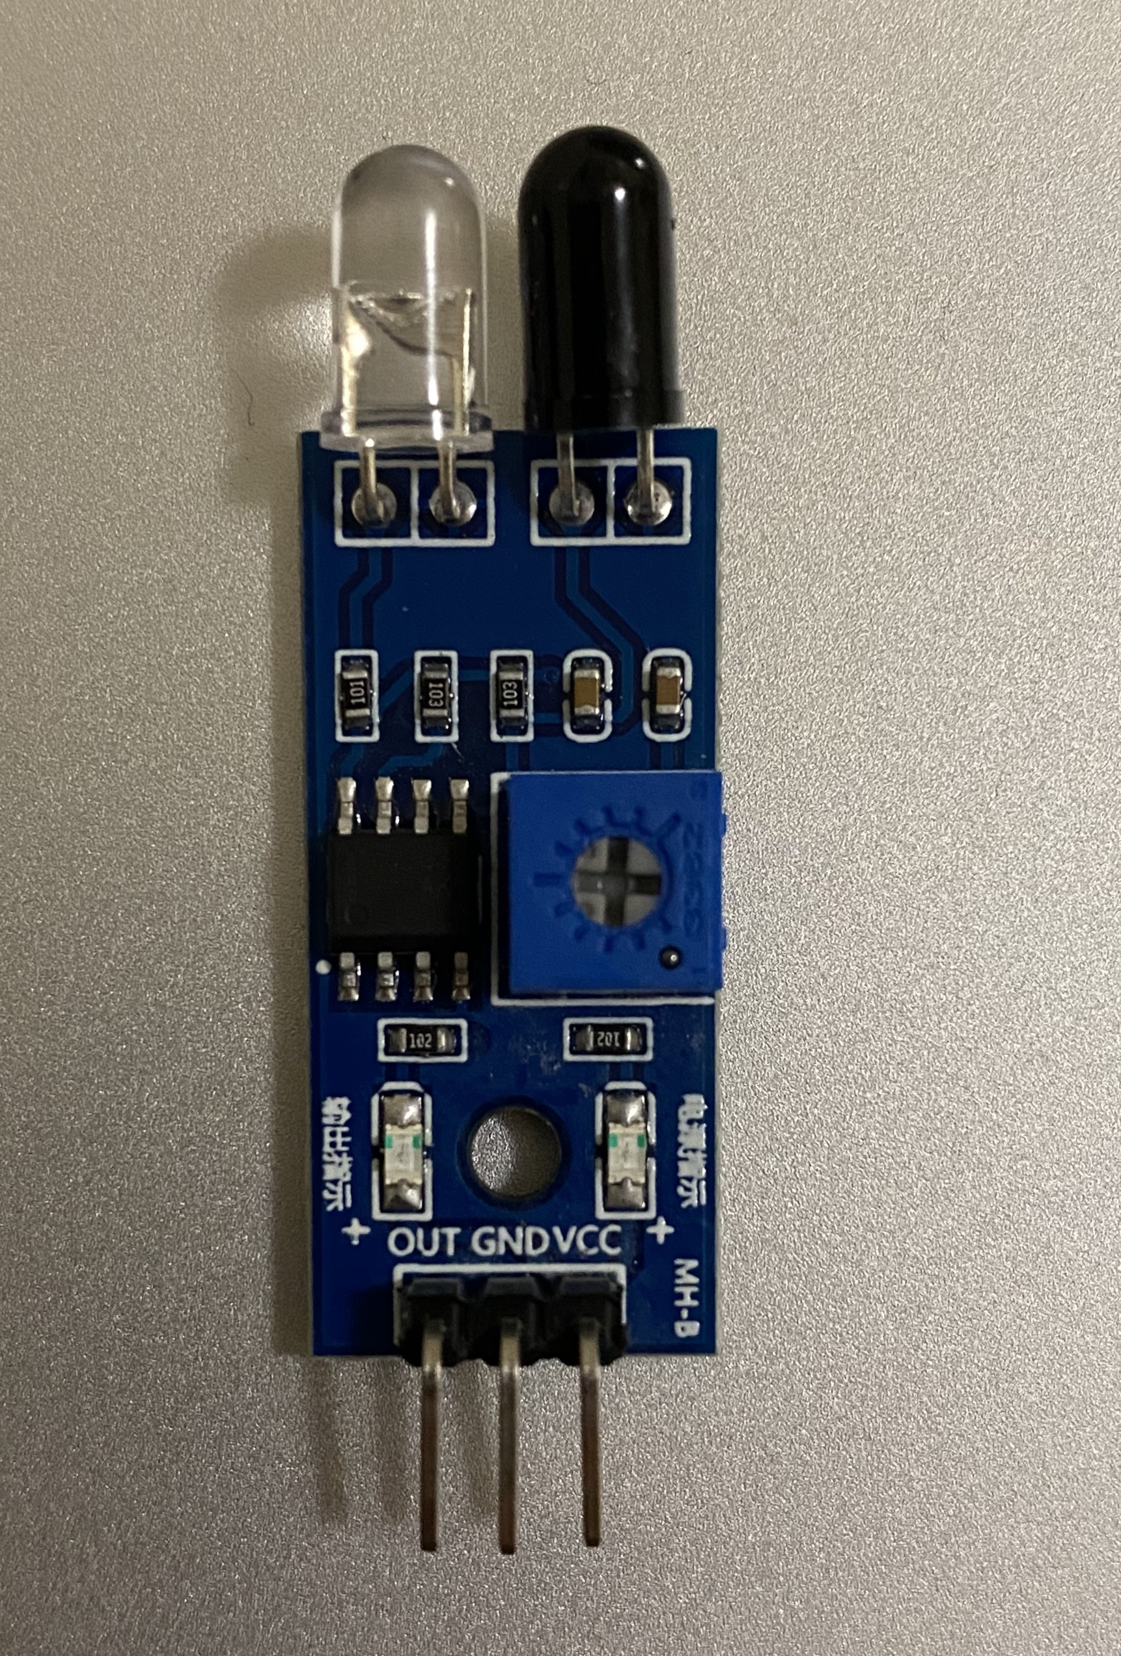

Fig. 4. IR Sensor

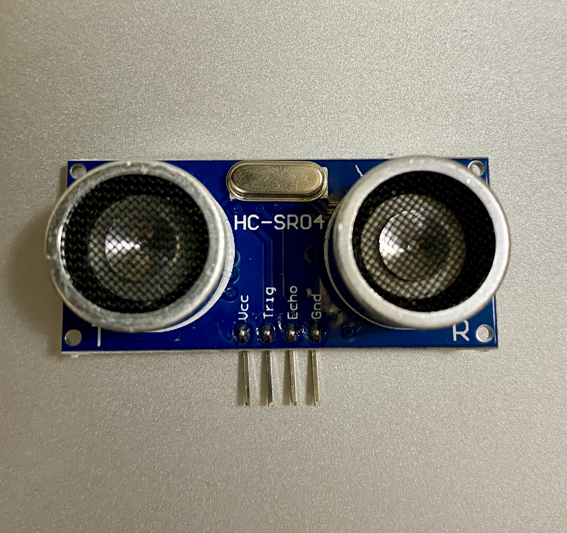

Fig. 6. Ultrasonic Sensor

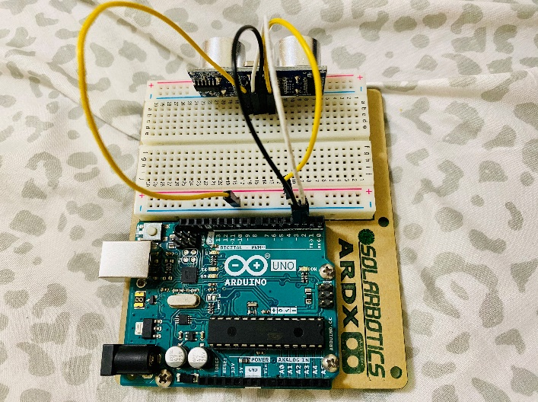

Fig. 8. Ultrasonic Sensor Interfacing

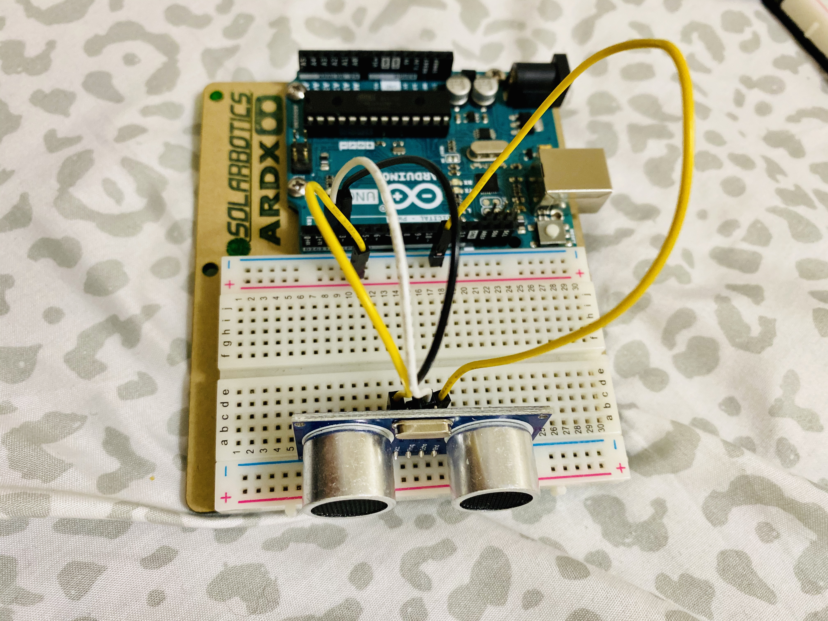

Fig. 7. Ultrasonic Sensor Interfacing

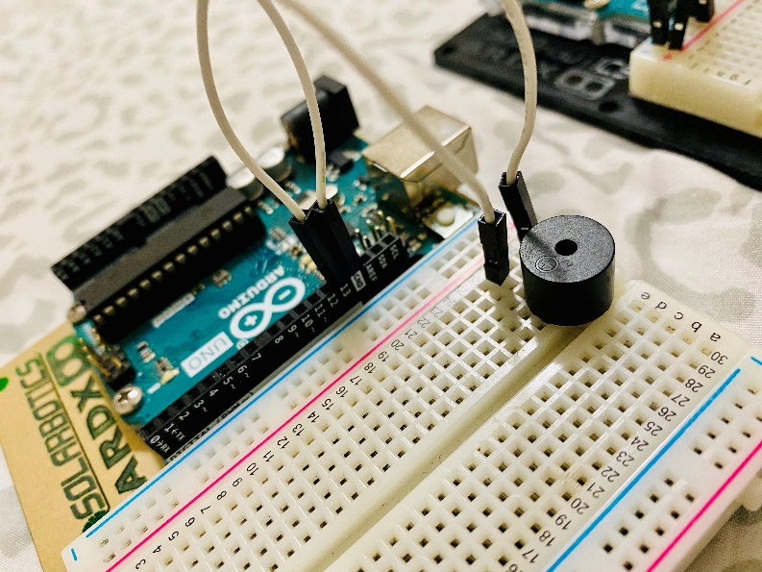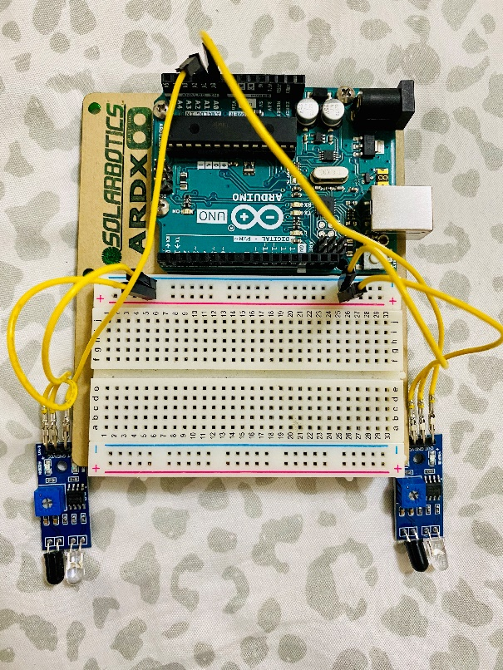

Fig. 10. Buzzer Interfacing

Fig. 9. IR sensors interfacing

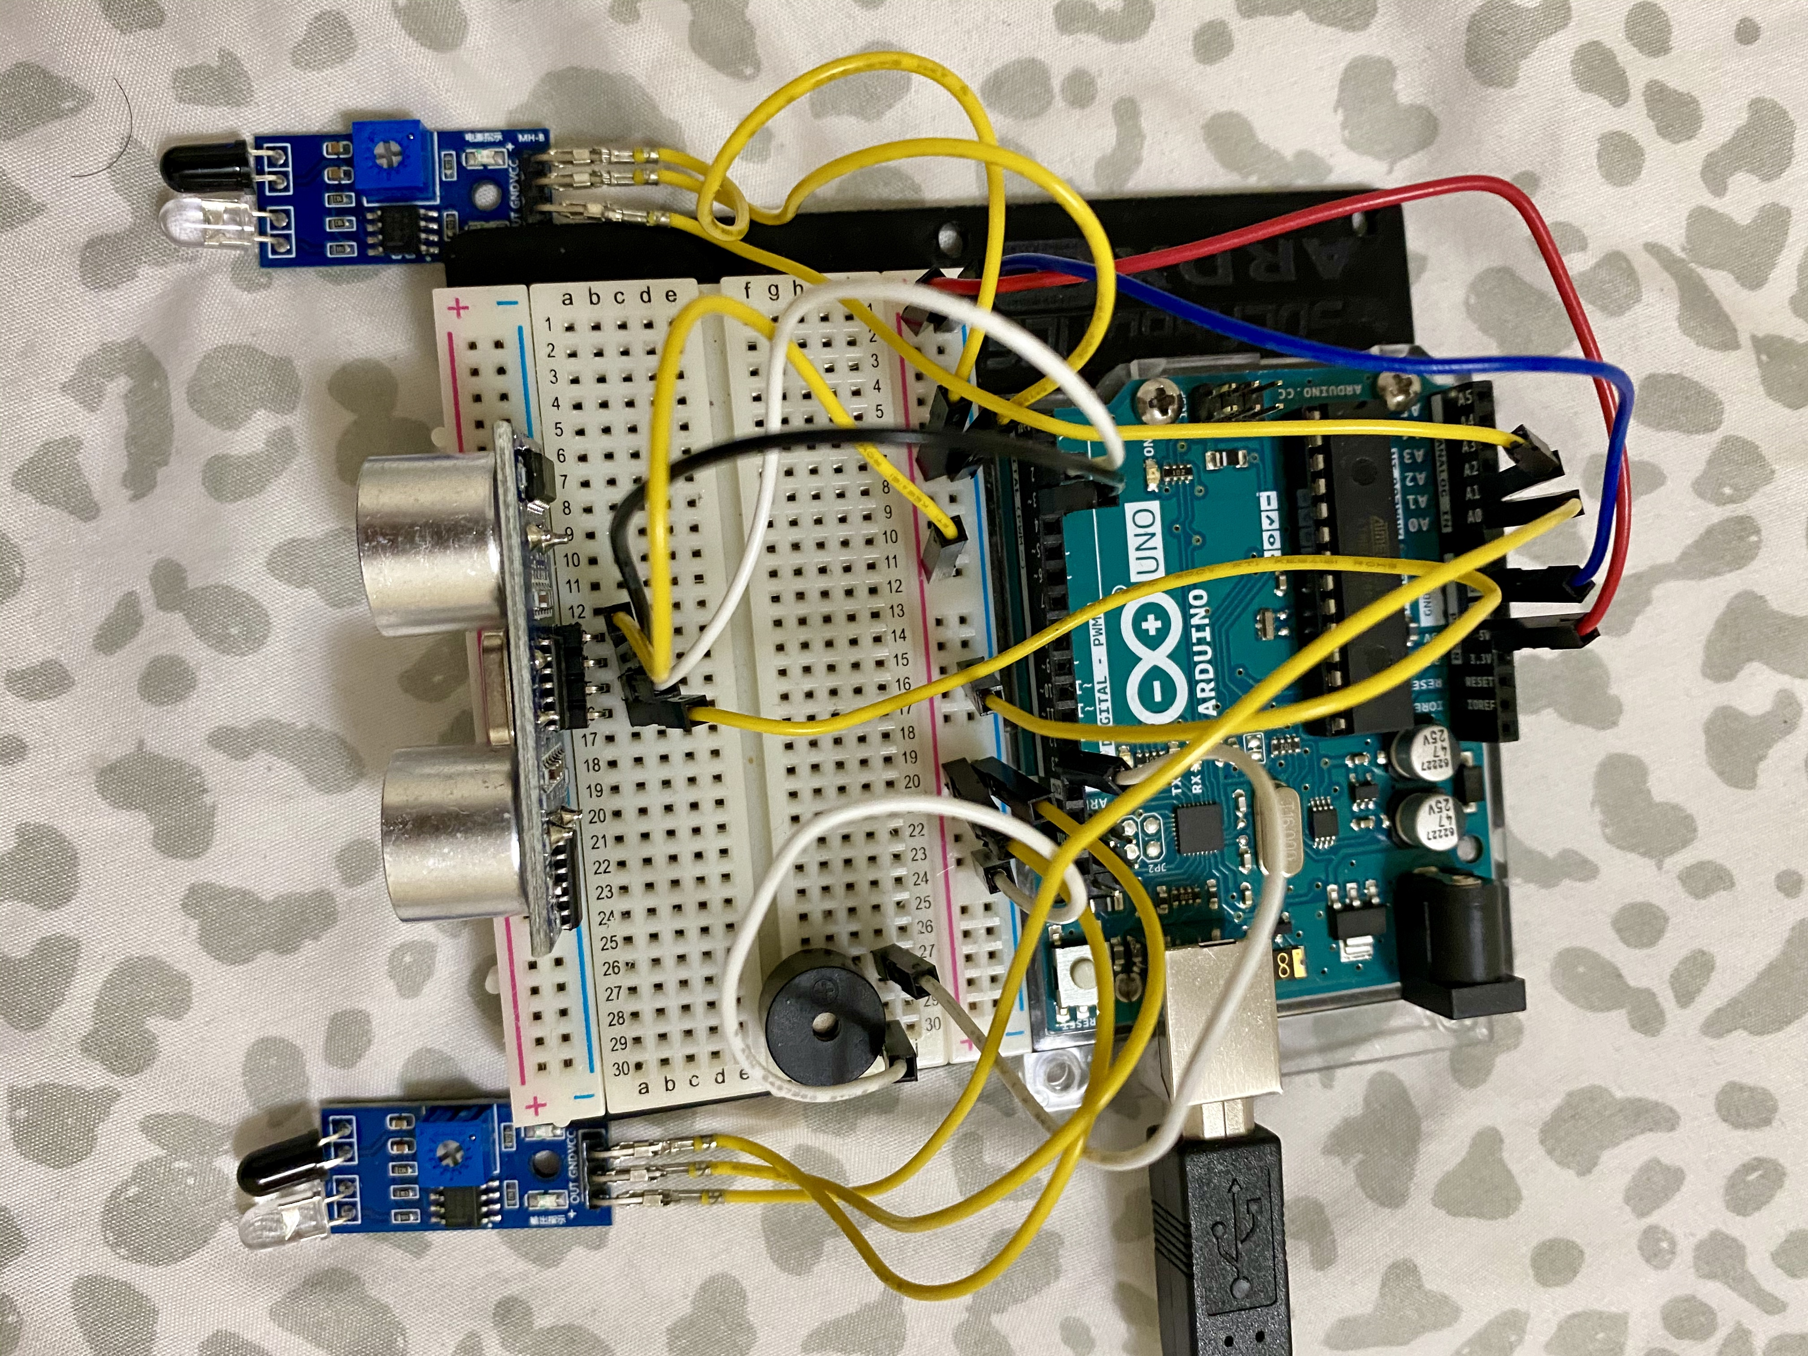

Fig. 11. System Test Prototype 1

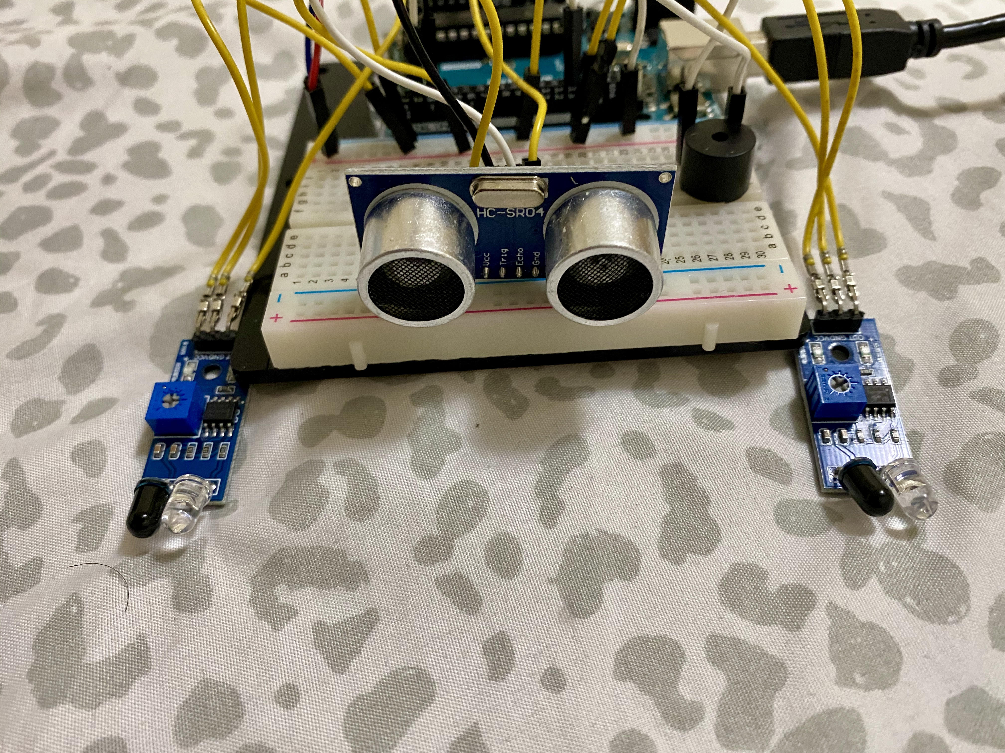

Fig. 12. System Test Prototype 1

Appendix C

Project Code: speed_pothole.ino

#define echoPin 2 // attach pin D2 Arduino to pin Echo of HC-SR04

#define trigPin 3 //attach pin D3 Arduino to pin Trig of HC-SR04

// defines variables

long duration; // variable for the duration of sound wave travel

int distance; // variable for the distance measurement

int timer1;

int timer2;

float Time;

int pole1 = 0;

int pole2 = 0;

float Distance = 5.0;

float speed;

int sensor1 = A0;

int sensor2 = A1;

int buzzer = 13;

void setup() {

pinMode(trigPin, OUTPUT); // Sets the trigPin as an OUTPUT

pinMode(echoPin, INPUT); // Sets the echoPin as an INPUT

pinMode(sensor1, INPUT);

pinMode(sensor2, INPUT);

pinMode(buzzer, OUTPUT);

Serial.begin(9600);

Serial.println("Ultrasonic Sensor HC-SR04 Test"); // print some text in Serial Monitor

Serial.println("with Arduino UNO R3");

}

void loop()

{

// Clears the trigPin condition

digitalWrite(trigPin, LOW);

delayMicroseconds(2);

// Sets the trigPin HIGH (ACTIVE) for 10 microseconds

digitalWrite(trigPin, HIGH);

delayMicroseconds(10);

digitalWrite(trigPin, LOW);

// Reads the echoPin, returns the sound wave travel time in microseconds

duration = pulseIn(echoPin, HIGH);

// Calculating the distance

distance = duration * 0.034 / 2; // Speed of sound wave divided by 2 (go and back)

// Displays the distance on the Serial Monitor

//Serial.print("Distance of the pothole: ");

//Serial.print(distance);

//Serial.println(" cm");

if (distance > 50)

{

Serial.println("Incoming pothole");

}

else {

//Serial.println("No pothole incoming");

}

if (digitalRead (sensor1) == LOW && pole1 == 0) {

timer1 = millis();

pole1 = 1;

}

if (digitalRead (sensor2) == LOW && pole2 == 0) {

timer2 = millis();

pole2 = 1;

}

if (pole1 == 1 && pole2 == 1) {

if (timer1 > timer2) {

Time = timer1 - timer2;

}

else if (timer2 > timer1) {

Time = timer2 - timer1;

}

Time = Time / 1000; //convert millisecond to second

speed = (Distance / Time); //v=d/t

speed = speed * 3600; //multiply by seconds per hr

speed = speed / 1000; //division by meters per Km

}

if (speed == 0) {

if (pole1 == 0 && pole2 == 0) {

//Serial.println("No vehicle detected");

}

else {

//Serial.println("Searching vehicle... ");

}

}

else {

Serial.print("Speed:");

Serial.print(speed, 1);

Serial.println("Km/Hr ");

if (speed > 50) {

Serial.println(" Over Speeding ");

digitalWrite(buzzer, HIGH);

}

else {

//Serial.println(" Normal Speed ");

}

delay(3000);

digitalWrite(buzzer, LOW);

speed = 0;

pole1 = 0;

pole2 = 0;

}

}

References

[1] Muhammad Ansar, *Car Speed Detector,* Retrieved 01 October 2020, from <https://create.arduino.cc/projecthub/embeddedlab786/car-speed-detector-d60ea0?ref=user&ref_id=598105&offset=25>.